**Revision History**

|  |  |  |  |
| --- | --- | --- | --- |
| **Date** | **Revision** | **Author** | **Changes** |
| 2022/1/24 | 1.0 | Tim | Initial version. |
| 2022/4/11 | 1.1 | Tim | Modified some api |

IP Description:

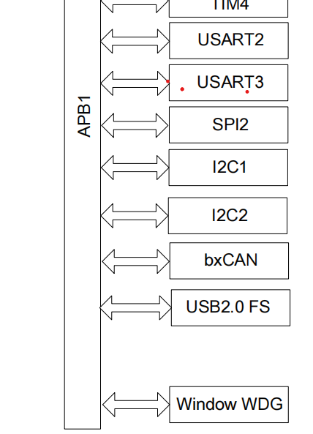

## Feature set: （功能列表）：

1.窗口看门狗

2.32位自由运行递减计数器

3.计数器可在debug模式下停止

4.时钟由APB1总线时钟分频

## Feature comparison with STM32: （跟STM32的功能比较）

|  |  |  |
| --- | --- | --- |
| 符号描述：   1. ✅支持 2. ❌不支持 3. ❌硬件有，但SDK计划不支持 | AT1K | STM32 |
| 窗口看门狗 | ✅ | ✅ |
| 独立看门狗 | ❌ | ✅ |

API Design:

|  |  |  |
| --- | --- | --- |
|  | AT103 | STM32 |
| init/de-init | void WWDG_Disable() | WWDG_DeInit |
| config | void WWDG_SetPrescaler(uint32_t WWDG_Higher_Prescaler, uint32_t WWDG_Lower_Prescaler); | WWDG_SetPrescaler(uint32_t WWDG_Prescaler) |
|  | void WWDG_SetresetpulseLength(uint8_t clockcycles)  void WWDG_Set_TimeoutRange(uint8_t clockcycles) | void WWDG_SetWindowValue(uint8_t WindowValue) |
| enable | void WWDG_Enable(uint8_t Counter) | void WWDG_EnableIT(void)  void WWDG_Enable(uint8_t Counter) |
| interrupt | FlagStatus WWDG_GetFlagStatus(void)  void WWDG_ClearFlag(void) | FlagStatus WWDG_GetFlagStatus(void)  void WWDG_ClearFlag(void) |